**PROJECT TOPIC: COMPARITIVE ANALYSIS OF VARIOUS MACHINE LEARNING ALGORITHMS IN STOCK MARKET**

**Group No. :10**

**Project Group Members:**

1. Vatsal Tewari (Sec B-69/151500599) **2.** Vaibhav Rai (Sec B-67/151500593)

**3.** Vivek Mishra (Sec C-84/151500628) **4.** Yash Agarwal (Sec D-75/151500636)

**Project Supervisor:** Mr. Maneet Singh, Assistant Professor, Department of Computer Engineering and Applications

**About the Project:** Our objective is to use various machine learning models to get prediction on stock market dataset and then decide which one of them stands out from the others and on which factors. This will hopefully provide the necessary consultation to one who wants to invest and is trying to decide the same. We would perform comparative analysis of different machine learning models such as Linear Regression, Decision Tree, Random Forest and maybe some more, with each model having its own prediction results, and efficiency on Stock Market Data and will try to get prediction percentage as high as possible. Our project is about concept efficiently analyzing the given data sets from anorganization or data in general and implementing data mining on that to uncover some hidden relations between details of customers and their probability of leaving, or not taking the offer.

**Motivation:** One who actively invests in stock market knows how much a headache it is to decide when and in which to invest. There are many indicators which are taken into account while taking these decisions. The successful prediction of a stock's future price could yield significant profit.

**Project Planning:** We will be presented with Data Set from quandl or yahoo finance on which we have to do modelling using various models such as Linear Regression and all else. And all this would be done through Machine Learning (M/L) algorithms using libraries available beforehand in Python or R(R is more fit for the purpose).

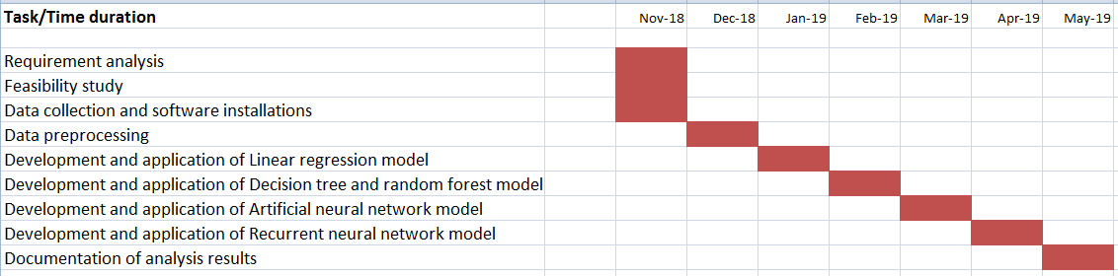

**Tools required:**

* **Hardware Requirements:**
* System with minimum of 4GB of main memory for smooth functioning of tools used to implement modelling.
* **Software Requirements:**
* Python or R IDE on which we will run our machine learning algorithms to model our data.
* Data Visualization which can be done through tools or using above mentioned programming languages IDE.

**Signature of Project Guide: _____________________**